**SOFTWARE**

**REQUIREMENTS SPECIFICATION**

**For**

# Job Portal System

**Prepared by:-**

Sandiya S

Sangamithra V

Sriharini EN

## 1. Introduction

### 1.1 Purpose

The main objective of this portal is to provide recruitment services to the public, individuals and companies. The job portal serves as a bridge between employers and job seekers by matching the specific skills demanded by employers with the skills possessed by candidates. This platform aims to streamline the job application process, enhance employer-employee matchmaking, and provide a user-friendly interface for effective and efficient hiring. This project describes the hardware and software interface requirements using ER diagrams and UML diagrams.

### 1.2 Document Conventions

* Entire document should be justified.
* Convention for Main title

Font face: Times New Roman



Font style: Bold

Font Size: 14

* Convention for Sub title

Font face: Times New Roman



Font style: Bold

Font Size: 12

* Convention for body

Font face: Times New Roman



Font Size: 12

### 1.3 Scope of Development Project

The scpoe of online job portal includes:

The online job portal system that is to be developed provides the users with job information, helps in applying for jobs online and many other facilities. The basic scope of the project is given as under.

Job seekers area

Agency's Area

Administrator's panel

### 1.4 Definitions, Acronyms and Abbreviations

JAVA -> platform independence

SQL-> Structured query Language

ER-> Entity Relationship

UML -> Unified Modeling Language

IDE-> Integrated Development Environment

SRS-> Software Requirement Specification

### 1.5 References

* Books

Software Requirements and Specifications: A Lexicon of Practice, Principles and



Prejudices (ACM Press) by Michael Jackson

Software Requirements (Microsoft) Second EditionBy Karl E. Wiegers



Software Engineering: A Practitioner’s Approach Fifth Edition By Roger S. Pressman

* Websites [**http://www.slideshare.net/**](http://www.slideshare.net/)

## 2. Overall Descriptions

### 2.1 Product Perspective

Use Case Diagram of Library Management System

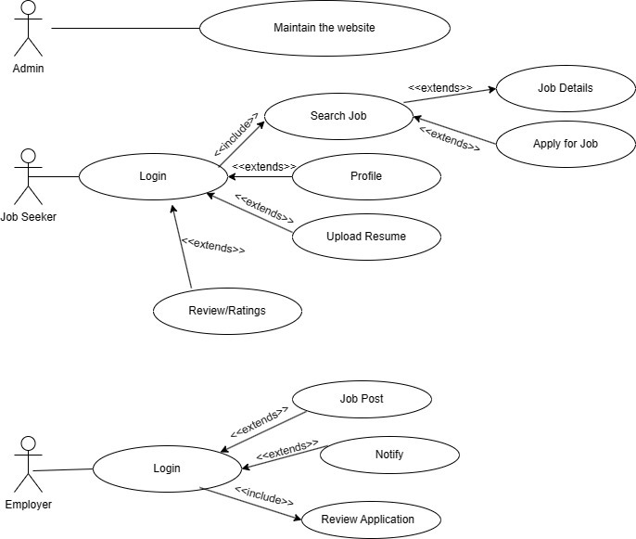

This is a broad level diagram of the project showing a basic overview. The users can be either employer or job seeker. This System will provide a search functionality to facilitate the search of jobs. This search will be based on various categories viz company name, salary, user profile. Further the employer can post job openings and select the right candidate for the job position. The job seekers can rate/review the company.

### 2.2 Product Function

Entity Relationship Diagram of Job Portal System

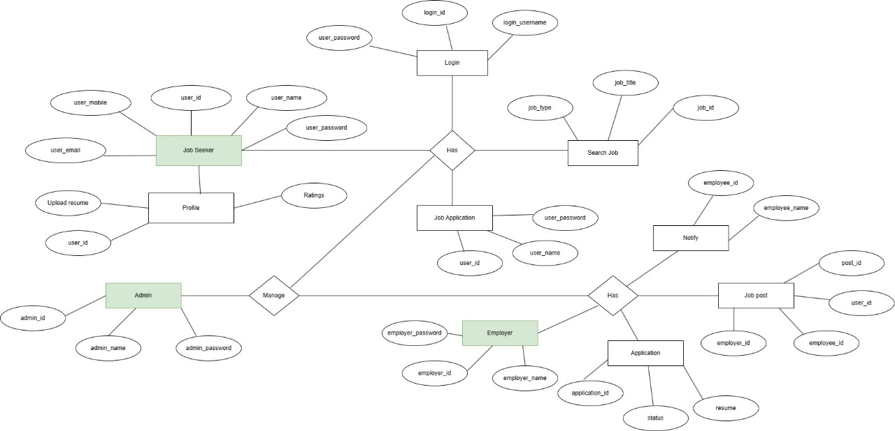

The Job portal System provides online real time information about the jobs currently in demand and the user information. The main purpose of this project is to reduce the manual work. This software is capable of providing job listings, application submission facilities, profile management, application tracking. There will be an administrator for maintaining the website . The employer is able to download and view the resume of the applicant. The users are allowed to view their account information and status of their application.

### 2.3 User Classes and Characteristics

The system provides different types of services based on the type of users[job seeker/Employer].

The features that are available to the user [job seeker] are:-

* Viewing Job Listings: Job seekers can browse and view job listings based on criteria like job title, job type etc.
* Application Submission: Job seekers can submit applications to job listings, including uploading resumes.
* Profile Management: Job seekers can create and manage their profiles, including personal details, work experience, education, and skills in their resume.
* Application Tracking: Job seekers can track the status of their applications and view the history of past applications.
* Search and Filters: Utilize advanced search options and filters to find specific job opportunities matching their skills and preferences.
* Notification Preferences: Set preferences for receiving notifications about application updates,if they are appointed for the job and other relevant events.
* Reviews and Ratings: Job seekers can leave reviews and ratings for employers based on their experiences.

The features that are available to the Employer are:-

* Job Posting: Employers can create and post job listings, specifying details such as job title, description, qualifications, and application deadlines.
* Application Management: Employers have the ability to review and manage applications submitted by job seekers.
* Account Management: Employers can edit their company profiles, manage job postings, and access the history of posted jobs.

### 2.4 Operating Environment

The product will be operating in windows environment. The Job portal System is a website and shall operate in all famous browsers, for a model we are taking Microsoft Internet Explorer,Google Chrome,and Mozilla Firefox.Also it will be compatible with the IE 6.0. Most of the features will be compatible with the Mozilla Firefox & Opera 7.0 or higher version. The only requirement to use this online product would be the internet connection.

The hardware configuration include Hard Disk: 40 GB, Monitor: 15” Color monitor, Keyboard: 122 keys. The basic input devices required are keyboard, mouse and output devices are monitor, printer etc.

### 2.5 Assumptions and Dependencies

The assumptions are:-

* The coding should be error free
* The system should be user-friendly so that it is easy to use for the users
* The information of all users, jobs and companies must be stored in a database that is accessible by the website
* The system should have more storage capacity and provide fast access to the database
* The system should provide search facility and support quick transactions
* The Job portal System is running 24 hours a day
* Users may access from any computer that has Internet browsing capabilities and an Internet connection
* Users must have their correct usernames and passwords to enter into their online accounts and do actions

The dependencies are:-

* The specific hardware and software due to which the product will be run
* On the basis of listing requirements and specification the project will be developed and run
* The end users should have proper understanding of the product
* The system should have the general report stored
* The information of all the users must be stored in a database that is accessible by the Job portal System
* Any update regarding the job from the company is to be recorded to the database and the data entered should be correct

### 2.6 Requirement

Software Configuration:-

This software package is developed using java as front end which is supported by sun micro system. Microsoft SQL Server as the back end to store the database. Operating System: Windows NT, windows 98, Windows XP

Language: Java Runtime Environment, Net beans 7.0.1 (front end)

Database: MS SQL Server (back end)

Hardware Configuration:-

Processor: Pentium(R)Dual-core CPU

Hard Disk: 40GB

RAM: 256 MB or more

### 2.7 Data Requirement

Designing the data requirements for a job portal, a comprehensive database should be established to seamlessly handle user queries and provide meaningful outputs. The system should capture detailed user profiles encompassing personal information, educational qualifications, work experience, and skills for both applicants and employers. Job listings, with essential details such as job title, description, qualifications, and application deadlines, form a crucial part of the database. Lastly, integration with external systems and regular maintenance are vital considerations for a dynamic and efficient job portal data model.

## 3. External Interface Requirement

### 3.1 GUI

The software provides good graphical interface for the user and the administrator can operate on

the system, performing the required task such as create, update, viewing the details of the job and job post.

➢ It allows user to view quick reports like job posted for user and notify the user if they were appointed for ths job in particular time.

➢ It provides stock verification and search facility based on different criteria.

➢ The user interface must be customizable by the administrator

➢ All the modules provided with the software must fit into this graphical user interface and

accomplish to the standard defined.

➢ The design should be simple and all the different interfaces should follow a standard

template

➢ The user interface should be able to interact with the user management module and a part

of the interface must be dedicated to the login/logout module

Login Interface:-

In case the user is not yet registered, he can enter the details and register to create his account.

Once his account is created he can ‘Login’ which asks the user to type his username and

password. If the user entered either his username or password incorrectly then an error message

appears.

Job Search and Listings:

Advanced search options for refining job searches based on criteria like location, industry, and salary.

Well-organized job listings with key information (title, company, location) displayed prominently.

Filters and sorting options for a personalized job search experience.

Application Process:

Clearly defined steps for applying to a job, with an option to upload resumes and cover letters.

Intuitive application forms with progress indicators.

Confirmation messages and status updates upon successful submission.

Reviews and Ratings:

Sections for users to leave and view reviews and ratings.

Clearly displayed ratings and reviews.

Option to submit and read feedback.

## 4. System Features

The users of the system should be provided the surety that their account is secure. This is

possible by providing:-

➢ User authentication and validation of members using their unique member ID

➢ User Verification is used for Verifying and approve new user registrations to prevent fake accounts and ensure data accuracy. Account Administration is used to Assist the users with account-related issues, such as password resets or account recovery.

➢ Proper accountability which includes not allowing a user to see other user’s

account. Only administrator will see and manage all accounts

## 5. Other Non-functional Requirements

### 5.1 Performance Requirement

The proposed system that we are going to develop will be used as a platform for employers and job seekers to interact. Therefore, it is expected that the database would perform functionally all the requirements needed.

* The performance of the system should be fast and accurate
* Job portal System shall handle expected and non-expected errors in ways that prevent loss in information and long downtime period. Thus it should have inbuilt error testing to identify invalid username/password
* The system should be able to handle large amount of data. Thus it should accommodate high number of data and users without any fault

### 5.2 Safety Requirement

The database may get crashed at any certain time due to virus or operating system failure. Therefore, it is required to take the database backup so that the database is not lost. Proper UPS/inverter facility should be there in case of power supply failure.

### 5.3 Security Requirement

* System will use secured database
* Normal users can just read information but they cannot edit or modify anything except their personal and some other information.
* System will have different types of users and every user has access constraints
* Proper user authentication should be provided ➢ No one should be able to hack users’ password
* There should be separate accounts for admin and members such that no member can access the database and only admin has the rights to update the database.

### 5.4 Requirement attributes

* There may be multiple admins creating the project, all of them will have the right to create changes to the system. But the members or other users cannot do changes
* The project should be open source
* The Quality of the database is maintained in such a way so that it can be very user friendly to all the users of the database
* The user be able to easily download and install the system

### 5.5 Business Rules

A business rule is anything that captures and implements business policies and practices. A rule can enforce business policy, make a decision, or infer new data from existing data. This includes the rules and regulations that the System users should abide by. This includes the cost of the project and the discount offers provided. The users should avoid illegal rules and protocols. Neither admin nor member should cross the rules and regulations.

### 5.6 User Requirement

The users are assumed to have basic knowledge of the computers and internet browsing. The administrators of the system should have more knowledge of the internals of the system and is able to rectify the small problems that may arise due to disk crashes, power failures and other catastrophes to maintain the system. The proper user interface, user manual, online help and the guide to install and maintain the system must be sufficient to educate the users on how to use the system without any problems.

The admin provides certain facilities to the users in the form of:- ➢ Backup and Recovery

* Forgot Password
* Data migration i.e. whenever user registers for the first time then the data is stored in the server
* Data replication i.e. if the data is lost in one branch, it is still stored with the server
* Auto Recovery i.e. frequently auto saving the information
* Maintaining files i.e. File Organization
* The server must be maintained regularly and it has to be updated from time to time

## 6. Other Requirements

### 6.1 Data and Category Requirement

The system encompasses Job Seekers, who possess the ability to search and apply for jobs, as well as update their profiles. Employers, on the other hand, have the privilege to post and manage job listings, review applications, and search for potential candidates. The Admin role holds comprehensive control, with the capability to modify user data, manage job listings, and address disputes. In terms of job categories, various domains such as Information Technology, Sales and Marketing, Finance, Healthcare, Engineering, Customer Service, and Human Resources have been identified. Each category encapsulates a curated list of relevant jobs along with associated data, providing a structured format for efficient navigation and information retrieval within the job portal system.

### 6.2 Appendix

A: Admin, Abbreviation, Acronym, Assumptions; B: Business rules C: Class, Client, Conventions; D: Data requirement, Dependencies; G: GUI;

O: Operating Environment;

P: Performance, Perspective, Purpose;

R: Requirement, Requirement Attributes,References;

S: Safety, Scope, Security, System Features;

U: User, User Class and Characteristics, User Requirements;

### 6.3 Glossary

The following are the list of conventions and acronyms used in this document and the project as well:

* Administrator: A login id representing a user with user administration privileges to the software
* User: A general login id assigned to most users
* SQL: Structured Query Language; used to retrieve information from a database
* SQL Server: A server used to store data in an organized format
* Layer: Represents a section of the project
* User Interface Layer: The section of the assignment referring to what the user interacts with directly
* Application Logic Layer: The section of the assignment referring to the Web Server. This is where all computations are completed
* Data Storage Layer: The section of the assignment referring to where all data is recorded ➢ Use Case: A broad level diagram of the project showing a basic overview
* Class diagram: It is a type of static structure diagram that describes the structure of a system by showing the system’s cases, their attributes, and the relationships between the classes
* Interface: Something used to communicate across different mediums ➢ Unique Key: Used to differentiate entries in a database

### 6.4 Class Diagram

A class is an abstract, user-defined description of a type of data. It identifies the attributes of the data and the operations that can be performed on instances (i.e. objects) of the data. A class of data has a name, a set of attributes that describes its characteristics, and a set of operations that can be performed on the objects of that class. The classes’ structure and their relationships to each other frozen in time represent the static model. In this project there are certain main classes which are related to other classes required for their working. There are different kinds of relationships between the classes as shown in the diagram like normal association, aggregation, and generalization. The relationships are depicted using a role name and multiplicities. Here ‘Employer’, ‘Job seeker’ and ‘Jobs’ are the most important classes which are related to other classes.

